Solution Requirements
Team ID | Date | Project | Maximum Marks
SWTID-2026-1237 | 29/09/2026 | EduGenie | 4 Marks

Functional Requirements:
Following are the functional requirements of the proposed solution.
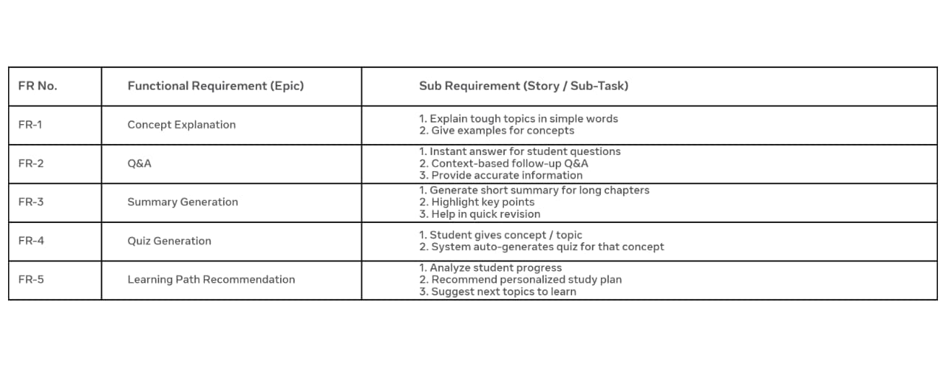
Non Functional Requirements:
Following are the non functional requirements of the proposed solution.
